**POINT OF SALES (POS) AND INVENTORY SYSTEM**

**FOR EPHRAIM`S HARDWARE SHOP**

A Capstone Presented to College Faculty

Of ACLC College of Apalit

**In Partial Fulfillment of the Requirements for the Degree**

**Bachelor of Science in Information Technology**

**Major in Web Application Development**

By

Ochoa John Bryan P.

Adora, Joshua S.

Mallari, Mary Preciosa P.

Mr. Lorenz Cortez

**Adviser**

**ACLC College of Apalit**

**Emmanuel Computer Learning Institute. Inc**

**Sulipan Apalit Pampanga**

**This Capstone Project Titled “POINT OF SALES AND INVENTORY SYSTEM FOR EPHRAIM`S HARDWARE SHOP” prepared and submitted by John Bryan P. Ochoa, Joshua S. Adora, Mary Preciosa P. Mallari in partial fulfillment of the requirements in Capstone Project for the degree of Bachelor of Science in Information Technology major in Web Application has been examined and is recommended for approval and acceptance.**

**LORENZE CORTEZ**

**Adviser**

**JANIS S. LOPEZ JONALYN O. GONZALES**

**INSTRUCTOR Academic Affairs Head**

**ACLC College of Apalit**

**Emmanuel Computer Learning Institute. Inc**

**Sulipan Apalit, Pampanga**

**APPROVAL SHEET**

**This capstone entitled “POINT OF SALES AND INVENTORY SYSTEM FOR EPHRAIM`S HARDWARE SHOP”, prepared and submitted by John Bryan P. Ochoa, Joshua S. Adora, Mary Preciosa P. Mallari was finally presented and successfully defended before the here under named panel of examiners on June 20, 2022 and is hereby accepted in partial fulfillment of the requirements for the degree Bachelor of Science in Information Technology major in Web Application Development.**

**JANIS S. LOPEZ, MEP-ECE**

**Chairman and ICT Coordinator**

**JONALYN O. GONZALES**

**Academic Affairs Head**

**LORENZE CORTEZ**

**Adviser**

**ACKNOWLEDGEMENT**

First and foremost, we thank God for assisting me and my colleagues in finishing this assignment on time. Despite several difficulties, my group completed this job, which makes us very delighted.

Then, thank you to **Mrs. Janis Lopez**, our capstone instructor, for being such a wonderful mentor to us while we accomplished this project. She shares information and innovative ideas that excite and drive us to finish our studies. **Mr. Lorenz Cortez**, our consultant, we thank you for your assistance with our system and for providing comments or ideas to help us finish it. Thank you for sharing your expertise, **Mr. Marcelo Yutuc.**

To the **ACLC COLLEGE OF APALIT**, where I am pursuing a Bachelor of Science in Information Technology, I would like to express my gratitude.

Lastly, a great thank you to our family and friends who did everything they could to support us, whether it was by encouraging us to keep going or by offering financial aid to meet all of the expenditures associated with this study.

**DEDICATION**

This research is dedicated to our dear parents, who have always been a source of inspiration and courage when we were about to give up, and who continue to provide moral, spiritual, emotional, and financial support.

To our siblings and relatives, instructors, acquaintances, and classmates who, through their words of advice and support, motivated us to complete our research.

Lastly, we would like to thank the Almighty God for his guidance in authoring this book. Mind power is the mental strength that gives us protection, abilities, and the ability to live a healthy life.

**ABSTRACT**

A Point of Sale and Inventory System is a software-based business system that keeps track of both sales and inventory. The EPHRAIM STORE Sales and Inventory Framework was developed to give a system for resolving existing issues at the EPHRAIM STORE in Apalit, Pampanga. In the current system, there is no evidence that making sales and inventory transactions are complex, resulting in reporting delays. Another difficulty to consider in this context is keeping track of what comes in and out. The researchers suggested the Sales and Inventory System to highlight current challenges.

This system can scan barcodes, add objects to databases, and save information about products, customers, and staff using barcode scanners. It may offer weekly, monthly, and yearly sales data, as well as advise the owner on which items are the top sellers through the use of pie graphs, line graphs, and bar graphs.

Both manufacturers and merchants may benefit from a comprehensive system that includes single transaction entry records, crucial client information, purchased items, and rate and date updates. The Inventory Point of Sale System is a computer that analyzes data to make more accurate and fast decisions. By far, an automated record surpasses a manual method. Rather than having separate notepads and files for each item that has to be filtered within the system, everything is captured in a single record.

The study's purpose is to automate the end-to-end transaction on Ephraim Store sales and inventory operations so that items can be readily tracked and inventory reports can be produced on time. Such goals will help to ensure a smooth operation flow as well as the generation of timely and accurate reports for submission and compilation.

**INTRODUCTION**

A point of sale and inventory system is a software-based business solution for tracking sales and inventories at the same time. A comprehensive system that records relevant facts on the client, products purchased, price, and date while continuously updating inventory levels can benefit both manufacturers and trade resellers.

Inventory and product management can be much more accurate when using computerized sales and inventory systems. As transactions are processed and products transferred from the company to the consumer, they facilitate easy communication between employees and customers. It also enables better marketing, inventory, and control of key sales targets. Businesses save time with computerized sales and inventory systems because they speed up transactions while providing accuracy. This increases employee trust in accounting and accountability because it is simple to check how much money was spent and when transactions happen.

They also make it possible to have a consistent customer service experience. People are aware that there is a systematic contact at the counter, which includes making payment, receiving a receipt, and transferring ownership of goods and services. This builds trust in a company and ensures long-term customer relationships. In retail markets, computerized systems are the most common method of inventory control and sales processing.

A point-of-sale system with an inventory tracking system can help a business calculate when to order material to minimize stock loss and how to avoid having too much inventory on hand. It might reduce earnings.

**CHAPTER I**

**BACKGROUND OF THE STUDY**

Technology is crucial because it influences almost every area of our lives. In other words, it satisfies the majority of human demands and solves many of their issues. Throughout the years, technology has evolved from a simple computer device invented by a single person to a complex system requiring the programming and maintenance of many individuals.

Ephraim Inusensio is a welder, so he decided to open a store that sells welding equipment, which he named the Ephraim Shop. However, the Ephraim Shop struggled to take orders and keep track of their sales because they only had manual transactions and recording, so the researchers recommended the Point of Sale and Inventory System to Ephraim.

Although a company's inventory control system and the point-of-sale system can be integrated, once the integration is in place, the system can automatically generate a purchase order and reorder items. Managers can conduct reports using a point-of-sale system that show not only how many of each item was sold but also which items were the most popular. Owners can also use point-of-sale data to identify seasonal trends in their item sales and maintain inventory on the shelf to capitalize on these opportunities.

If the business uses an automated inventory system to save and validate its data and checks, the system's figures may be accurate, but a hand count or manual counting may be required to ensure the system's integrity and avoid missing data. The tracking and reporting features of these systems make achieving goals more transparent, and having a Point-Of-Sale system reduces the amount of paper used, making the task easier.

**GENERAL OBJECTIVE**

Our study's major goal is to create a point-of-sale system that can computerize, standardize, and correlate retail data for business purposes while also making transactions simple and hassle free.

**SPECIFIC OBJECTIVES**

1. Help the store manage the data of the following:

1.1 to Improve Inventory System

1.2 to easily monitoring of Sales

1.3 to improve the transaction Payment

1.4 The user can easily:

1.4.1 Add Data to database

1.4.2 Delete Data to database

1.4.3 Update Data to database

2. Provide a better transaction by using:

2.1 Automated Point-of-Sale System

2.2 GCash Transaction (Optional)

3. Provide the effectiveness of the system measured in terms of the following:

4.1 Functionality

4.2 Reliability

4.3 Usability

4.4 Security

4.5 Maintainability

**SCOPE AND LIMITATION**

This proposed system will improve Ephraim Store's day-to-day business transactions in order to deliver better customer service. Between the user and the system, the platform has an easy-to-use interface.

User Information

* The admin can search and retrieve the user`s information.
* The admin can add and update the user’s information if needed.
* The user can view his information. The user can also update his or her password if necessary.

Point-of-Sale System

* This system helps make transactions faster.
* The system can help the store be more productive.
* The system lessens the miscalculation and to be more accurate.
* The system helps you improve your operations for your customers.

Inventory

* Adding a new product to inventory
* Editing or updating the product price
* Deleting a product to the inventory
* Searching/Retrieving a product to the inventory
* Can see/view the remaining stocks of every product.
* Reduce the Risk of Out-Of-Stock Problems
* Simplify Inventory Management
* Accurately Forecast Future Sales
* The system is using SQL Database

Transaction History / Transaction Report

* Can generate transaction reports based on the given date.
* Can confirm the warranty of the receipt
* Can export to excel
* Can view transaction details
* Can update transaction by the authorized user when there's an error in transaction

Sales Report

* Can see/view the product sale, revenue sale and warranty list based on the given date.
* Can generate sales reports based on the given date.
* Can export to excel file

**LIMITATION**

The proposed system has its restrictions. Thus, it will not cover the following:

* Online Reservation
* Discount System
* Online payment
* Information on the internet.
* Refund process.

**Significance of the Study**

The proposed system is made for the benefit of the following:

**Ephraim’s Hardware Shop**

The suggested solution will automate Ephraim's Hardware Shop and present manual transactions and inventory, addressing the store's current difficulty.

This can record data quickly while still being dependable and accurate, which will improve data sorting and customer service. Data recording is simple with the suggested approach, and calculations are more precise.

**Cashier**

The cashier at Ephraim's Hardware Shop can make his or her job easier by using the computerized system, which streamlines data sorting and recording. Because of the COVID-19 pandemic, speedier transactions can help to prevent the virus from spreading between the cashier and the consumer.

**Customers**

Customers are the business's source of revenue, so they should be treated with respect and receive prompt service. Customers will not have to wait long to purchase goods. Customers will receive better service as a result. Result of the business's quick and accurate service.

**Future Researchers**

Future researchers might use this as a resource to gain ideas and solutions for problems they may encounter during their research. This will aid future researchers in the development of computerized systems and the development of new features.

**ACLC College of Apalit**

People will see that the school can generate students who are competitive and efficient in the field of information technology as a result of this project.

**CHAPTER II**

**Related Literature**

This chapter contains the ideas of the completed thesis generalizations or findings techniques and other information. Those in this chapter aid in familiarizing readers with relevant and similar information to the current study. This chapter includes a review of related literature and studies that are relevant to the point-of-sale system study proposal. It also incorporates theories, literature, and research on the proposed system. This chapter provides a conceptual framework that demonstrates a preliminary understanding of how the proposed project will be developed, as well as an overview of works in a specific field of study.

**HARDWARE**

**BARCODE READER-** A barcode reader is an optical scanner that can read printed barcodes, decode the information, and send it to a computer. Similar to a flatbed scanner, it consists of a light source, a lens, and a light sensor that converts optical impulses into electrical signals.

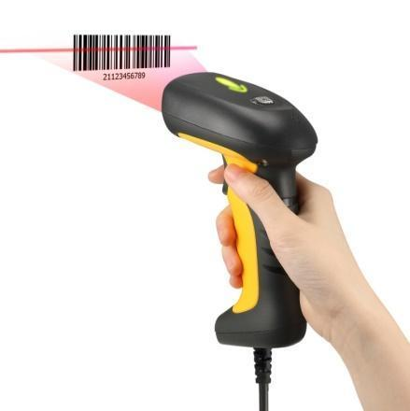

**Figure 1.1 Barcode Scanner**

**BLUETOOTH PRINTER**- A printer is a computer device that produces a permanent image of graphics or text on paper. Barcode printers are an example of a printer's wider application, even if the majority of output is human readable. In printers, Bluetooth is used to allow cordless and wireless printing. Without any physical connections, Bluetooth printing allows your computer to deliver print jobs directly to your printer. Even if your computer and Bluetooth printer are in different rooms, you may send print jobs at a data transmission speed of up to 3 Mbps, which is quite quick.

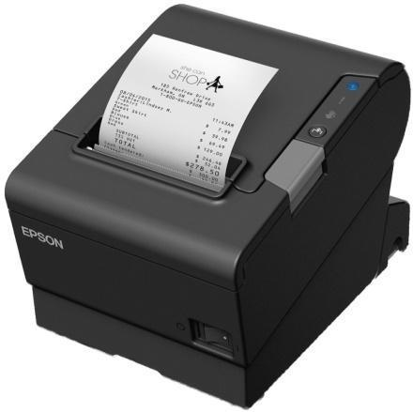

**Figure 1.2 Receipt Printer / Thermal Printer**

**Desktop PC/Laptop**- A computer is a mechanism or equipment that follows instructions from a software or hardware program to perform procedures, calculations, and operations. It can accept data (input), process it, and then output results. Computers can also store data in appropriate storage devices for later use and retrieve it as needed. 

**Figure 1.3 Desktop or Laptop Device**

**Software/Programming Languages**

**XAMPP**- is an acronym for cross-platform, Apache, MySQL, PHP, and Perl, and it allows you to create a WordPress site on your computer's local web server. The "cross-platform" component refers to the fact that this simple and lightweight solution works on Windows, Linux, and Mac.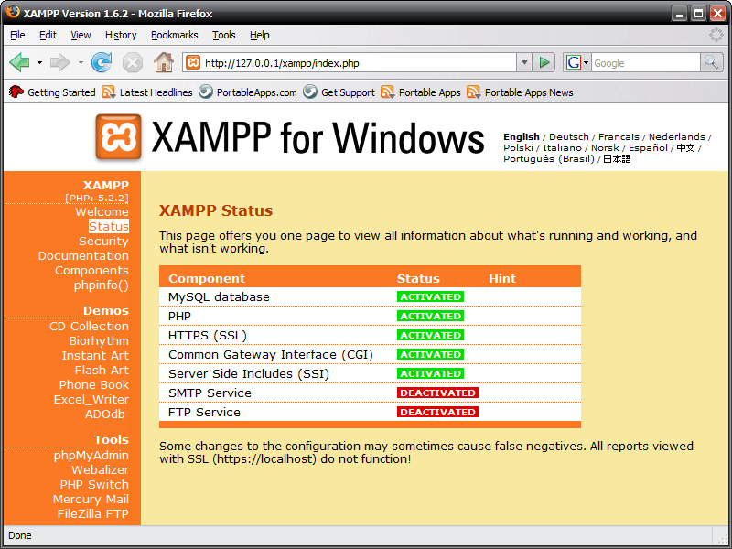

**Figure 1.4 XAMPP Sever**

**IntelliJ IDEA-** is a Java-based integrated development environment for creating computer software. JetBrains created it, and it comes in two flavors: an Apache 2 Licensed community edition and a proprietary commercial edition. Both can be used to establish a business.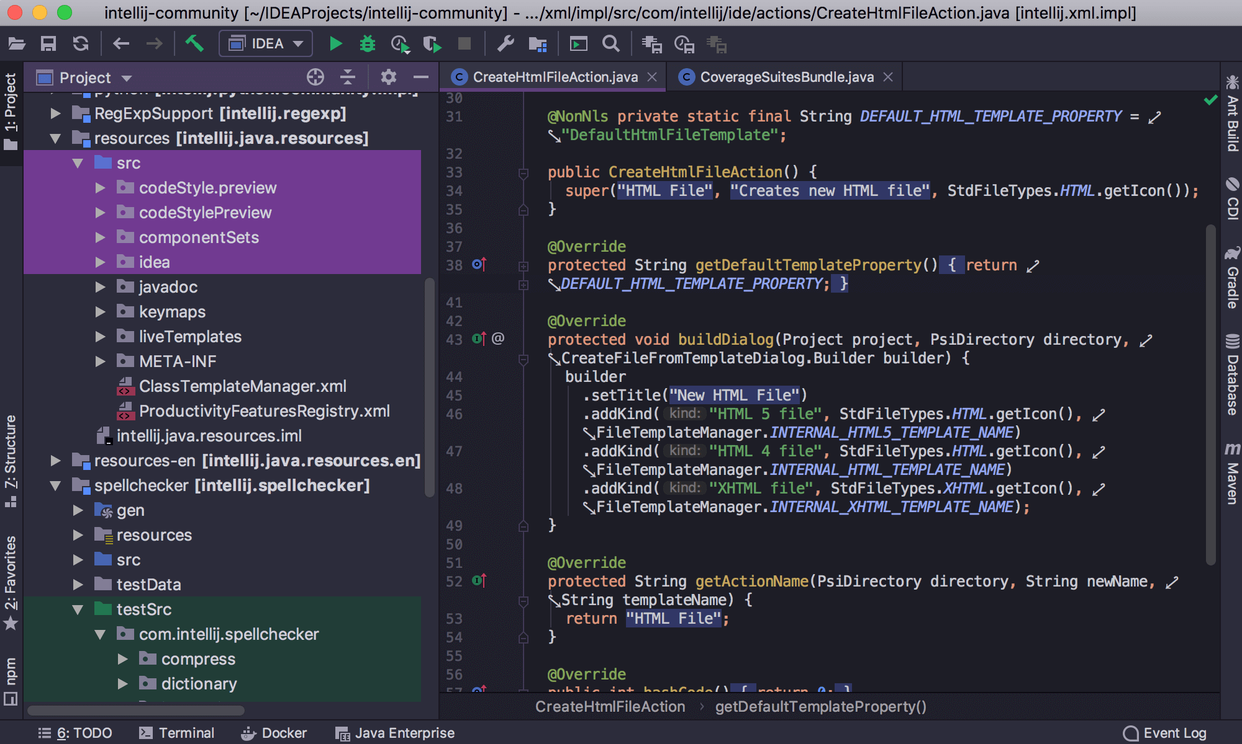

**Figure 1.5 IntelliJ IDEA Application**

**Local Related Study(s)**

**7 Reasons why your small business needs a POS (Point-of-Sales) System**

A powerful business management solution such as a POS system is important for any small business owner – retail, F&B, or service. And you’ve probably heard of the term POS or point-of-sale somewhere before. So what are the benefits of a POS system? And does your small or medium business even need one?

So a POS or point-of-sale system is the combination of software and hardware that is used to centralize business management.

Point-of-sale refers to the point of where the sale happens.

A POS system is basically your high-powered, hulked out, Jarvis of a cash register. I mean, if Tony Stark had a brick-and-mortar business, he’d be using a POS system. So you should too!

**Digital payment grows in Philippines amid COVID-19 fears (July 2020)**

**By:** Jun Endo and Nikkei Staff Writer

The Philippines has been lagging behind its neighbors in adopting digital payment, according to Jun Endo and Nikkei Staff Writer, but is gradually catching up. "Financial technology should be considered the backbone of digital services in a world where digital is the new normal," Pebbles Sy, chief technology and operations officer of Globe Fintech Innovations, or Mynt, which manages the GCash service, stated in mid-May. "Aside from the ease, it's also safer than dealing with cash, more efficient than physical payments, and transparent," he told local media. According to GCash, the total quantity of payments made on its platform in May increased by eightfold year over year. With 20 million registered users, GCash is the Philippines' largest mobile wallet. The service is available in 63,000 stores, the majority of which are tenants in commercial buildings run by Ayala Corp., the diversified conglomerate that owns Globe Telecom. Consumers have been sluggish to adopt digital currency, preferring cash despite marketing initiatives. By 2023, the country's central bank wants electronic payments to account for half of all payments in terms of volume. According to a report published in December by the Better Than Cash Alliance, a United Nations-based coalition of governments, enterprises, and international organizations aiming at speeding the transition from cash to digital payments, the percentage had only reached 10% by volume by 2018. "With the advent of mobile money in 2001, the Philippines was a global early-mover in digital payments...(but) the path to widespread adoption and usage has not been smooth," according to the paper. Thailand and Indonesia are currently using digital money more than the Philippines. However, the pandemic has served as a strong motivator for electronic payment. Most establishments were forced to close due to the lockout, which made it difficult for customers to pay at bank or store counters. While the harsh quarantine rules were reduced in June, individuals and companies must still take steps to guarantee social distance. This has sparked a significant shift toward digital money, which is supposed to minimize the spread of germs that could otherwise be conveyed by bills and coins. Both GCash and PayMaya are concentrating their efforts in areas where digital currency demand is likely to surge. With government funding, GCash will assist in the provision of equip taxis with QR code-based scan-to-pay systems. Users will pay by using their smartphones to scan QR codes posted on fare meters.

**Foreign Related Study(s)**

**Point-Of-Sales (October 2020)**

**By:** Adam Hayes

According to Adam Hayes, the point of sale (POS), an important component of a point of purchase, is the location where a client makes a payment for goods or services and where sales taxes may be due. It could be a physical store with POS terminals and systems processing card payments, or a virtual sales point like a computer or mobile electronic device.

Consumers prefer to make purchasing decisions on high-margin items or services at these critical locations, hence POSs are an important target for marketers. Businesses have traditionally placed POSs near store entrances in order to improve the percentage of spontaneous purchases as customers leave. Changing POS locations, on the other hand, might provide merchants with more opportunity to micro-market specific product categories and affect customers sooner in the sales funnel.

Department shops, for example, frequently feature POSs dedicated to specific product groupings, such as appliances, electronics, and clothes. Rather than simply processing transactions, the dedicated staff can actively market products and advise consumers through purchasing selections. Similarly, the format of a point-of-sale (POS) can influence profit or purchasing behavior because it provides customers with a variety of purchase options.

Amazon Go, a concept convenience store that uses technology to allow customers to stroll in, take things, and leave without having to go through a register, could revolutionize POS systems. This might allow POSs, loyalty, and payments to be merged into a single customer-centric experience, in addition to enhancing ease.

Electronic point-of-sale software systems help retailers run more efficiently by automating transactions and keeping track of critical sales data. An electronic cash register and software to manage data acquired from everyday purchases are among the most basic systems. Installing a network of data-capture devices, such as card readers and barcode scanners, can help retailers improve functionality.

Retailers can track price accuracy, inventory fluctuations, gross revenue, and sales patterns depending on the program capabilities. Using integrated technology to track data allows merchants to detect pricing or cash flow anomalies that could result in profit loss or sales interruption. POS systems that track inventory and purchasing patterns can help merchants avoid issues like out-of-stock sales and customize purchasing and marketing to client preferences.

**POINT OF SALE FOR INVENTORY MANAGEMENT (January 2021)**

By: Rosemary Carlson

A point-of-sale (POS) is the location where clients of a small business exchange money for the items or services supplied by the small business, according to Rosemary Carlson. A POS transaction occurs when a customer purchases or returns a product or service at a physical store, via a mobile app, or through an internet checkout.

A basic cash register, a single computer, or an integrated computer network with point-of-sale software can all be used as a POS system. It could also be a mobile device such as a laptop, tablet, phone, or customized terminal that can be used to conduct online sales transactions from a distance. POS terminals can be either permanent equipment connected to a computer within a store, mobile units like an iPad, or internet transaction units.

POS systems can be used in a number of different ways. Small firms that offer things will benefit the most from them. Businesses that sell products or utilize things that they want to track in their production process would benefit from POS systems that track inventory. These technologies are a valuable addition to the inventory management toolkit of any company.

**Case Study: Automated payments and dynamic discounting fuel growth at Media fly (May 2016)**

**By:** John Evarts

According to John Evarts, "A client requested that transactions be conducted on the Ariba Network because it is the world's largest and most worldwide business network, with over two million organizations in 190 countries," and "we began sending all of our invoices electronically." Everything changed after that. Using SAP Ariba's business network's connection and analytics gave us the simplicity and agility of cloud-based solutions while also allowing us to better manage the full payment cycle. The network served as a quick and secure electronic environment for exchanging purchase orders and invoices, as well as delivering comprehensive remittance data and payments that revealed exactly what they represented at the invoice and line-item level. We used Ariba's Invoice Management and Discount Professional software to fully automate the process of providing, negotiating, and agreeing on early payment conditions. We were able to reduce the time it took from quote to settlement from 30 to 90 days to just 14 days thanks to Discount Professional. We were able to get the funds we needed to fuel Media fly's expansion faster than would have been possible or even imaginable with traditional financing sources since we cut the turnaround time in half. Our buyer's ability to pay invoices to us ahead of time through dynamic discounting has been the biggest advantage. We used the money to speed up our engineering hiring process, which resulted in tremendous business development. We were also able to release a product ahead of plan, which was a big success, thanks to this early cash. The achievement of business milestones and company growth is closely tied to automating our payment operations and providing early payment discounts. The benefit of receiving the money sooner has considerably surpassed the cost of providing the discount. Furthermore, as our company developed in revenue and staff, the network became a valuable resource for new business, exposing us to a large number of potential clients.

**Auto CRUD Automation IFML Specification of CRUD Operation (May 2016)**

**By:** Roberto Rodriguez-Echeverria, José M. Conejero, Juan C. Preciado, and Fernando Sanchez-Figuero

Development and deployment solutions for data-intensive web applications have advanced significantly in recent years, according to Roberto Rodriguez-Echeverria, José M. Conejero, Juan C. Preciado, and Fernando Sanchez-Figuero. These technologies include domain-specific frameworks and Model-Driven Web Engineering techniques. They have enabled these systems to address implicit issues such as rapidly changing business norms and stringent time-to-market constraints. The automation of redundant development tasks is a critical component of both methodologies' success. CRUD activities are an excellent example of a repetitive and recurrent process that can be automated. Despite the fact that online application frameworks include means for automating the implementation of CRUD tasks, Model Driven Web Engineering methodologies have mostly ignored them, and their automation has yet to be effectively addressed. Auto CRUD, a Web Ratio plug-in that automates the development of CRUD operations in the OMG IFML (Interaction Flow Modeling Language) standard, is presented in this work. The tool's applicability was determined by its use in multiple real-world projects created by a software company specializing in model-driven web application development. The collected results demonstrate the tool's tremendous productivity gain, which almost completely eliminates developer time spent on CRUD operation implementation.

**Importance of Point of Sales Software in the Philippines (2021)**

By: Juan C. Preciado

According to Juan C. Preciado, in the Philippines, point-of-sale systems are gradually replacing traditional cash registers for the better. The point-of-sale system has revolutionized sales efficiency and accuracy. The system is adaptable to a wide range of operations and may be customized for any organization. These systems have made counter work a lot easier and more manageable. The other two areas that have benefited significantly from the implementation of this program are administration and accounting. The importance of point-of-sale software in the Philippines is discussed in this article. There are numerous advantages to using point-of-sale software. POS Philippines is a sales point management system that automates and manages many functions. Its principal purpose is to keep track of all orders placed and sales made. When compared to typical billing techniques, the entire procedure takes less time. Keeping track of sale information in a database allows you to access it whenever you need it for analysis and verification. This system's UI is particularly user-friendly, allowing sales representatives to respond more quickly. The sales personnel are given a touch screen UI to help them work faster. Order tracking and kitchen order routing are automated in POS built for restaurants, reducing time lapses and liabilities. In this area, less human interference leads to increased efficiency. At regular intervals, the database is updated with every detail put in the system. To preserve data integrity across locations, the local database is also synced with the SAP database. This helps the prompt placement of orders for the essential items and provides for hassle-free inventory tracking. In case of any issues, the sales representative can also view inventory details in the operational system. Maintaining real-time data allows business managers to run their operations more efficiently. From the convenience of your workplace, you may monitor all transactions as they occur. This saves you a significant amount of time traveling between sales locations.

Each user's access permissions in the system are restricted to allow just a limited set of operations in order to protect data integrity. This stops anyone from altering the system's figures. The administrative and financial teams are given the greatest levels of access due to the amount of data they require for their jobs. The system has the capability of recording logs of every update and deletion, ensuring that any changes are closely monitored.

The system can be simply customized to meet the needs of any organization. You can also configure the fields and a few screen options right away. A central SAP database makes it easier to keep all sales data in one place. One change in the central database affects all local databases, preventing pricing and item detail conflicts. Get more information on our SAP Hotel Management Software. The system handles all of the credit and debit transactions. From here, every last detail is recorded in the database. This makes your accounting clearer and makes tax computation easier in the system. This will save you a significant amount of time and work. All financial data is meticulously recorded, including dates. This is very helpful during auditing procedures. You may also see how much you spend on inventory and your profit margin on a monthly and annual basis. These data are critical in terms of corporate expansion. This software's main feature is reporting. To aid in analysis and other business operations, this software generates a range of customizable and exportable reports. When creating these reports from the system, you can specify the parameters and time periods. These reports are necessary for doing business trends and sales history analyses and research. These particulars aid in the development of a strong business plan for the following months and years. Sound decision support assists you in growing your firm to new heights.

**System reliability, performance and trust in Adaptable Automation (January 2016)**

By: Alain Chavaillaz, David Wastell and [Jürgen Sauer](https://pubmed.ncbi.nlm.nih.gov/?term=Sauer+J&cauthor_id=26360226).

According to Alain Chavaillaz, David Wastell and [Jürgen Sauer](https://pubmed.ncbi.nlm.nih.gov/?term=Sauer+J&cauthor_id=26360226), in an adaptable automation context, the consequences of lower system reliability on operator performance and automation management were investigated. 39 operators were randomly allocated to one of three experimental groups: low (60%), medium (80%), or high (100%) automation support reliability. The support system offered five levels of incremental automation, which operators may choose from according to their requirements. Operator performance and automation management were tested during a 2.5-hour testing session after 3 hours of training on a simulated process control task (Auto CAMS) in which the automation performed flawlessly. Questionnaires were also used to gauge trust and workload. Although lower levels of faith in automation were associated with worse levels of system reliability, there were no variations in the operators' dependence on automation. While operators demonstrated a remarkable capacity to cope with automation failure in general, there were significant reductions in diagnostic speed and prospective memory with decreased reliability. The implications of decreasing system reliability on operator performance and automation management in an adaptable automation environment were investigated in this study. 39 operators were randomly allocated to one of three experimental groups: low (60%), medium (80%), or high (100%) automation support reliability. The support system offered five levels of incremental automation, which operators may choose from according to their requirements. Operator performance and automation management were tested during a 2.5-hour testing session after 3 hours of training on a simulated process control task (Auto CAMS) in which the automation performed flawlessly. Questionnaires were also used to gauge trust and workload. Although lower levels of faith in automation were associated with worse levels of system reliability, there were no variations in the operators' dependence on automation. While operators showed a notable ability to cope with automation failure in general, there were decreases in diagnostic speed and prospective memory with reduced reliability, indicating that system reliability influences both trust and dependence. (e.g., Wiegmann et al., 2001; Bailey and Scerbo, 2007; Ma and Kaber, 2007). However, system reliability may not necessarily have the same effect on attitude and behavior. Rovira et al. (2007), for example, found an effect primarily on quantitative variables like performance and automation use, whereas other studies found the opposite effect, impacting only subjective measures like trust. (Dzindolet et al., 2003). A similar dissociation of subjective trust and objective trust-related behavior was also observed in a study by Manzey et al. (2012), which suggested that subjective trust ratings responded to variations in automation reliability more closely than automation management behavior (e.g., information sampling of critical system parameters).

**Automated System and Security: Threats and Advantage (June 2018)**

By: Larry Alton

According to Larry Alton, in most modern sectors, automation is the most powerful driver of change. Automation is expected to completely replace over 800 million jobs by 2030, and in the meantime, automation is transforming how we work, plan our businesses, and interact with others. The main benefit of automation is cost savings; if you spend $500 per month to have a machine do the work of a salaried employee earning $3,000 per month, you can easily save $2,500 per month ($30,000 per year). Apps like automated payment systems, automated marketing software, and even automated trading software are becoming increasingly available and inexpensive for small and mid-sized firms because of general technological developments.

But with the rise in automation, there will be new security threats, and conversely, some security advantages, to watch for the advantages. Predictability **-** Automated systems are designed to work the same way in all circumstances (with some exceptions for platforms driven by machine learning). This means the actions they take are almost entirely predictable; any actions they take that are “safe,” will remain safe indefinitely, and any security vulnerabilities can be identified and fixed, because they’ll repeat themselves. This makes it easier to control individual engagements with the system, like monetary transactions or content publications. Reduction of human errorIt’s estimated that about 90 percent of cyber security breaches are at least partially attributable to human error. Using automated systems instantly and significantly reduces that risk of error. Humans will be responsible for logging into and managing things on the platform, but they won’t be participating in every transaction or action item. That means fewer vulnerabilities overall, and fewer worries about an unfamiliar or undereducated employee making a foolish mistake that compromises your system. Scalability **-** Most automated platforms are designed to scale as well; because they function just as efficiently with a few tasks as they do with several thousand (provided there is enough computing power, storage, etc.), they can easily adapt to almost any company’s needs even as they grow. This means you won’t have to worry as much about hiring new people, training new people on security standards, or investing in bigger and better solutions every time you go through a growth spurt.

The Threats will be Provider vulnerabilities - Security breaches are becoming insanely common, and [74 percent of companies that suffer one](https://www.esecurityplanet.com/network-security/74-percent-of-companies-that-suffer-a-data-breach-dont-know-how-it-happened.html) don’t even know what’s happened. If you purchase an automated system through an external provider, and they have a glaring security vulnerability they weren’t able to catch, it could render your entire system vulnerable. Working with a third-party automation platform means you’ll be susceptible to whatever vulnerabilities that third party brings to the table. Integration loopholes - Because most automated systems need to integrate with other systems to serve your company (whether it’s drawing data from another platform or exchanging information with another system), you’ll need at least a handful of API connections to make things work. Unfortunately, each of those connections is another potential vulnerability. If you aren’t communicating using encrypted exchanges and secured channels, your data could become vulnerable especially if it’s all happening in the background. Lack of oversight - Unfortunately, many IT officers and employees start to develop a sense of complacency when automated systems are handling the bulk of their original responsibilities. In some cases, entire roles are outright replaced. In any case, there’s a significant drop in the oversight for individual actions, and often lackluster alert systems in place to notify IT when there’s a breach or an abnormality in the system.

**Review of Related Study**

A computer-based system is a multi-faceted system that heavily relies on information technology. It simplifies the task, speeds it up, and enhances its accuracy. As a result, the automated system has become essential for both small and large enterprises in order to give the best services available. In today's economic climate, even small and mid-sized businesses have come to rely on computerized inventory management systems. Obviously, manual inventory tracking is still used by many small merchants, manufacturers, and other businesses. Most businesses nowadays use cutting-edge technology to streamline their operations. They use computerized methods to handle their transactions based on their requirements. Fast food restaurants, pharmacies, grocery stores, and other businesses all employ point of sale systems.

Every firm needs a point of sale and inventory system since strong sales and inventory management can lead to increased productivity. Input, output, and restocking are the three main components of inventory work. Input is the process of adding new products to the inventory and replacing outdated ones. Meanwhile, output is a procedure of taking out the products from the inventory for sales or usage and refill is a process of increasing the number of existing products in the inventory in order to fulfill the insufficient products or escalating demands. Most of the retailing market is using traditional way in the inventory management system where a person is assigned to check and record the stock by hand using pen and paper.

Creating a point-of-sales system for a hardware store can help them improve their business transactions with customers as well as their business process. As the proponents see it, the Hardware shop uses manual transactions, but the features of that manual are restricted and prone to human errors, which can lead to business conflict. The Proponents propose the Hardware shop Point of Sale System to help the Owner in terms of security, reliability and accuracy of every transaction. From a manual process, this system transforms the transaction into a modern way that will benefit a lot especially the cashier, employees, customers and the owner.

Your customer makes a payment for products or services at your store using a point-of-sale system, or POS. Simply explained, a customer completes a point-of-sale transaction every time they make a purchase. Beyond Online transaction processing, the latest point of sale software allows the hardware shop to add mobile POS features, contactless payment alternatives, ecommerce integration capabilities, and more.

**SUPRA RETAIL PLUS v2013**

Supra Plus has designed the ultimate architecture of a Windows-based Point of Sale (POS) system to meet a variety of retail needs. Fast food, bars, and restaurants may all benefit from our systems.

SUPRA PLUS is a computer that runs DELPHI Language applications that are specifically developed to perform cash register functions. With lightning speed and flawless performance, this tiny and wonderfully crafted software solution executes almost every cashier action known to humans.

       SUPRA PLUS offers an exhaustive set of cash register features combined with the universal hardware connectivity, software accessibility, and computational speed that only DELPHI Language programming can deliver.

**POS Reports**

      Supra Plus has a complete suite of reports that provides you with all the information required to run your business effectively and profitably. It has a report generator, which enables you to produce any reports specific to your accounts or properties.

      Supra Plus provides a summary of all day’s activity at the main server station, or for a particular clerk, or for the whole store.  It sums up sales, returns, and tax, paid in/out, credit cards sales; and sums up the in/out for special transactions, such as Gift Certificates, Charge Invoice and Debit Card.  It lists all checks accepted for the day with ID information.  It sums up all line-item discounts by the reasons they were given.

**Conceptual Framework**





**Figure 1.6 Conceptual Frameworks**

The system meets all of the necessary criteria to be accepted for further planning and development to the design phase, as illustrated in the diagram. As soon as the system was approved, we began working on the design. In the Process Phase, each step-by-step system method is built one by one. From databases to interface design, every procedure is well planned. Every improvement and advancement is documented in weekly progress reports. Adjustments are performed every day and week. If the required attributes are met, the proponents move on to the output.

**DEFINITION OF TERMS**

The following are terms that were operationally defined for a better understanding of the study:

**Java-** It is an object-oriented programming language that may be used to create applications for a variety of platforms. The compiled code, also known as byte code, created by a programmer for a Java application runs on most operating systems (OS), including Windows, Linux, and Mac OS. Java draws a lot of its syntax from C and C++.

**MySQL-** It could be anything from a basic grocery list to a photo gallery or the massive volumes of data in a business network. A database management system, such as MySQL Server, is required to add, access, and process data contained in a computer database.

**CRUD** – Create, Retrieve, Update and Delete

**POS** – Point of Sales

**Database** - An organized collection of structured information, or data, typically stored electronically in a computer system

**CHAPTER III**

**Methodology of the Study**

# **Design/Type of Research**

The researchers choose the study methods and techniques for designing research. The waterfall method is the design or type of research employed by researchers. Unlike other approaches, the waterfall methodology is one of the most effective research or study methods since it is simple and easy to implement.

# 



















**Figure 2.1 SDLC (Waterfall Method)**

**Project Development**

The System Development Life Cycle (SDLC) is a widely used methodology in software engineering and information technology for developing high-quality software. The SDLC technique focuses on the software development phases listed below:

1. **Planning Phase** - This phase involves analyzing and defining the current problem and determining how to solve it through the project. The second stage's goal is to define the breadth of the problem and find solutions. Resources, costs, time, and other factors should all be taken into account. The project plan, which identifies, prioritizes, and assigns the tasks and resources required to establish the framework for a project, is developed during the planning phase of the SDLC.
2. **Analysis Phase -** During this software development lifecycle phase, the specialists meticulously collect precise requirements from the customer to present a solution fine-tuned to their needs. Any unclarities must be elucidated in this stage only. The analysis phase also gathers business requirements and identifies any potential risks. This step in SDLC also includes a feasibility study, which defines all fortes and weak points of the project to assess the overall project viability.
3. **Design Phase -** High-Level Design (HLD) and Low-Level Design (LLD) are two more steps in the third phase (LLD). The former produces the future architecture of a software product, whereas the LLD step specifies how each feature of the product should function. The database specification is also produced during this phase to decide on data management and storage for future processing, retrieval, or review.
4. **Implementation Phase** - This step begins after the system has been tested and accepted by the user. The system is installed in this phase to support the required business functions. The system's performance is measured against the goals set during the planning phase. User notification, training, hardware installation, software installation on production computers, and system integration into regular work activities are all part of the implementation process. This phase will continue until the system is in production and meets the established user criteria.
5. **Testing Phase -** In the software development lifecycle (SDLC), the testing phase is where you focus on research and discovery. Developers determine whether their code and programming meet customer requirements during the testing phase. While it is impossible to eliminate all failures discovered during the testing phase, the results of this phase can be used to reduce the number of mistakes made inside the software program. The project team must first create a test plan before testing can commence. The test plan outlines the sorts of testing you'll do; testing resources; how the software will be tested; who should be the testers at each phase; and test scripts, which are the instructions that each tester follows when testing the product. While testing, test scripts assure consistency. Quality assurance testing (QA), system integration testing (SIT), and user acceptability testing are all forms of testing done throughout the test process (UAT).
6. **Installation Phase -** The final deployment procedure begins once the software testing step is completed and the system is free of defects and faults. The final program is released and reviewed for any deployment difficulties based on the project manager's feedback.
7. **Maintenance Phase –** The following are the three activities that occur once the system is deployed and clients begin to use the developed system.

**Bug fixing**–Bugs are reported because of some scenarios which were not tested at all.

**Upgrade** – Upgrading the application to the newer versions of the software.

**Enhancement** – Adding some new features to the existing software.

**Project Research Design**

Shows the method and process on how the flow of the system 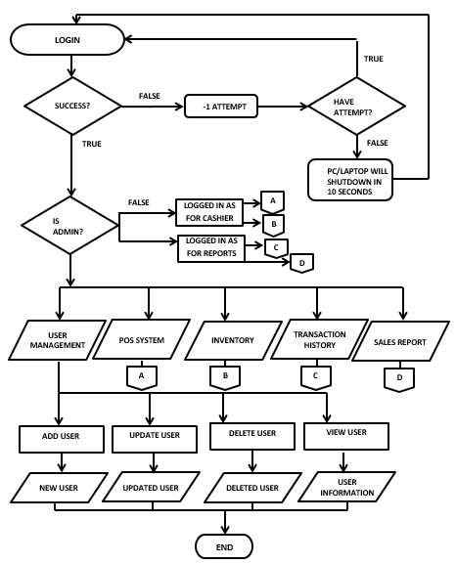



**Figure 2.2 This is the process of the Point of Sales System**

**CASHIER/ADMIN** 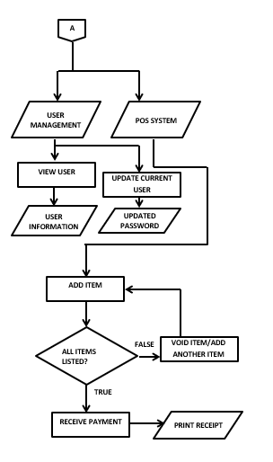

**Figure 2.3 This is the process of POS**

**INVENTORY/ADMIN**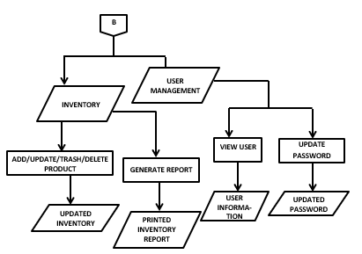

**Figure 2.4 This is the process of Inventory**

**FOR REPORTS/ADMIN**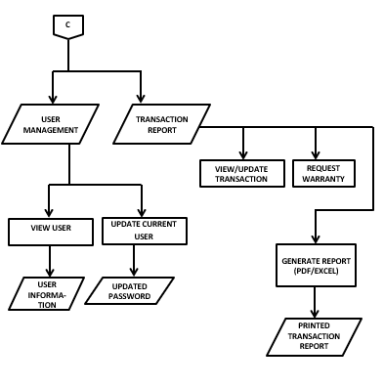

**Figure 2.5 This is the process of Transaction Report**

**FOR SALES REPORT/ADMIN**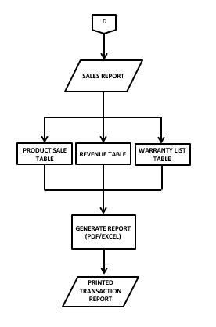

**Figure 2.6 This is the process of Sales Report**

**Evaluation Procedure**

To aid in the evaluation of the proposed system, the researchers present a survey questionnaire. This type of questionnaire provides uniform responses, making it easy to calculate the data required by the proposed system.

**Evaluation Criteria**

The following criteria will be used to determine whether the proposed system is of high enough quality to be implemented.

**Functionality** – Refers to the degree to which the proposed system is functional and capable of achieving the system’s objectives.

**Usability** – This refers to how easily the proposed system can be implemented.

**Reliability** – Refers to the degree to which the suggested system is trustworthy.

**Maintainability** – Refers to the ease with which a software flaw can be modified and fixed in order to keep it working.

**Security** – Refers to the ability to keep confidential data and transactions safe.

**Instrument and Technique Used**

A survey questionnaire is a research tool that consists of questions designed to obtain information from respondents. If researchers need to upgrade or change a system component, this will be helpful.

| **RATING** | **DESCRIPTION** |
| --- | --- |
| 4.50 – 5.00 | Strongly agree |
| 3.50 – 4.49 | Agree |
| 2.50 – 3.49 | Neutral |
| 1.50 – 2.49 | Disagree |
| 1.00 – 1.49 | Strongly Disagree |

**Figure 2.7 Rating and Description for Questionnaire**

**CHAPTER IV**

**Project Technical Description**

The end-to-end process of this point-of-sale system is that when you log in as an admin, you have access to all of the system's features, whereas when you log in as a cashier or employee, you don't have access to some of them, such as voiding products, updating user information, and adding, updating, and deleting products from inventory. This is the system's end-to-end process:

1. You can log in as an administrator or an employee during this part of the log-in procedure. The admin or owner's login and password are stored in the database.
2. The dashboard section, overview section, inventory section, user information section, transaction report section, sales report section, activity log section, and point of sale section are all visible in the mainframe during this phase.
   1. The main lobby is seen in the Dashboard section.
   2. The pie graph shows the top 5 best sales of the month, the bar graph shows the overall sales of the product, the line graph shows the profit on a daily basis for a month, and the total stocks tell the number of overall products in inventory, the product register tells the number of different kinds of products, and the total sales for today are all shown in the Overview section.
   3. To safeguard the data in the Inventory Section, you must re-login with the inventory login and password. You can add, update, and delete data in this part to avoid having too much data on your inventory list, but you can also completely delete the data if you choose.
   4. In the User Information section, you can see the information of each user, whether they are your employees or not. This section is only accessible by the owner or admin.
   5. You can see every transaction up to the point of sale in the Transaction Report area, and you can also produce the entire report and save it as an excel file.
   6. Every graph in the overview part of the table can be seen and printed in the Sales Report section.
   7. You can observe every activity in the system, such as login and logout, under the Activity Log section.
   8. Using a barcode scanner or by clicking on a product on the table, you can complete a sale transaction and add a product (s) to the order list. There is also a "void" button in this section that allows you to remove a product from the order list, but this feature is only available to users with the owner or admin ID. In this area, the user can also print a receipt for an organized list.

**Software Requirement**

**• Program Development Tools**

* IntelliJ
* XAMPP

**•Operating System**

* Windows 10

**Hardware Requirements**

* Mouse (any types of ports)
* QWERTY keyboard (any types of ports)
* LED or LCD Monitor 1TB SSD (for storage)
* 8gb of RAM
* Barcode Scanner
* Thermal Printer

**Cost and Benefits Analysis**

This shows the cost and benefits analysis of the proposed system.

| **PROJECT COST ESTIMATE** | | | | | |
| --- | --- | --- | --- | --- | --- |
| **COST (Annually)** | | | | | |
| **Work-Breakdown Structure**  **(WBS)** | **HOUR/DAY**  **Consumed** | **COST monthly** | **Subtotal** | **WBS Level**  **TOTAL** | **% Of Total** |
| **1.Project Management** |  |  |  | PHP 540,000 | **95.97%** |
| Programmer | 9 Hours per day | PHP 16,000 | PHP 192,000 |  |  |
| Project Manager | 9 Hours per day | PHP 19,000 | PHP 228,000 |  |  |
| Team Member/Freelance | 9 Hours per day | PHP 10,000 | PHP 120,000 |  |  |
| **2.Hardware** |  |  |  | PHP 22,150 | **3.93%** |
| PC or Laptop |  |  | PHP 20,000 |  |  |
| Barcode Scanner |  |  | PHP 700 |  |  |
| Thermal Printer |  |  | PHP 1300 |  |  |
| Thermal Paper |  |  | PHP 150 |  |  |
| **3.Testing** |  |  |  | PHP 500 | **.08%** |
| Tester | **1 Hour Per Day** | PHP 500 |  |  |  |
| **Total Project Cost Estimate** |  |  |  | **PHP 562,650** | **100%** |
| **BENEFITS (Annually)** | | | | | |
| Easy-to-Use PoS | | | | PHP 90.000 | |
| Computerize Database | | | | PHP 100.000 | |
| Sales Associates | | | | PHP 420,000 | |
| Inventory Control Specialist | | | | PHP 393,600 | |
|  | **Total Benefits** | | | **PHP 1,003,600** | |
| **NET PRESENT VALUE**  **(NPV)** | **∑** Present Value of Future Benefits  -**∑** Present Value of Future Cost | | | **PHP 440,950** | |
| **BENEFIT-COST RATIO** | **∑** Present Value of Future Benefits  **∑** Present Value of Future Cost | | | **1.78** | |

**Figure 3.1 Project Cost Estimated**

**Project limitations Capabilities**

Every transaction in Ephraim's Hardware Store is computerized with this method. This will aid the store's growth and improvement. The formulas and tactics for building a point-of-sale and inventory system will be based on recent studies and research. This is a stand-alone system that will be online. It also lacks the ability to accept credit or debit cards.

**Project Structured Organization**

**Login Frame**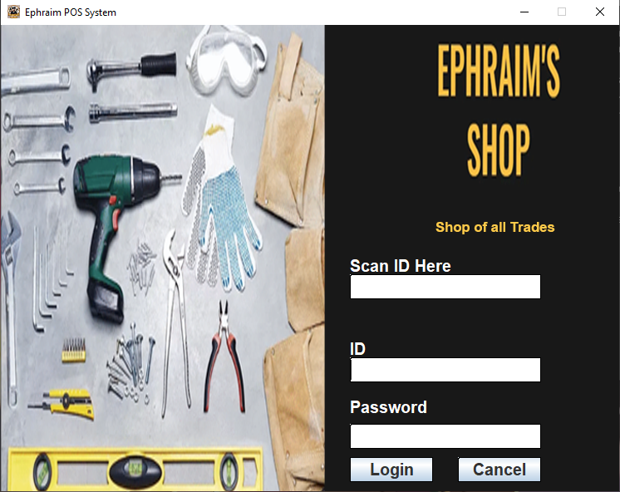



**Figure 3.2 The System Log-in Phase Interface**

**Point-of-Sales (PoS) Frame**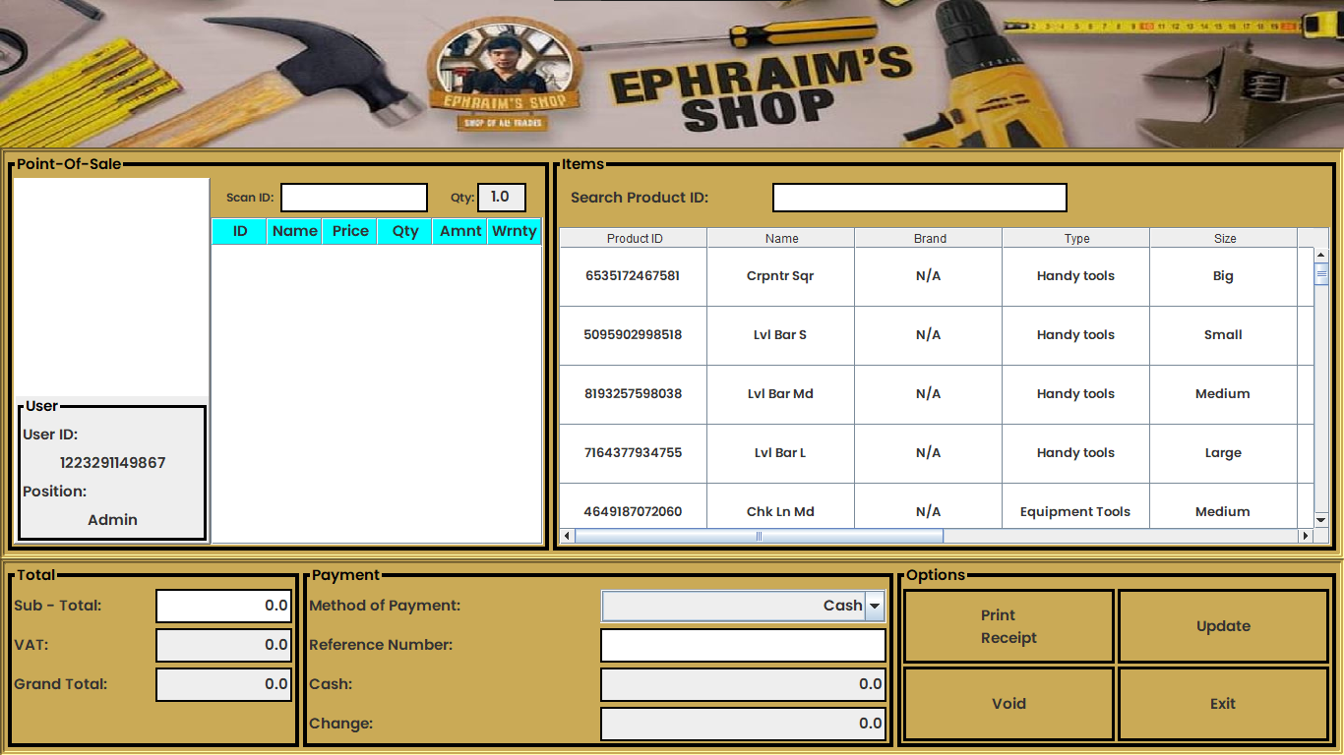

**Figure 3.4 The Point-of-Sales (PoS) Interface**

**Dashboard Frame**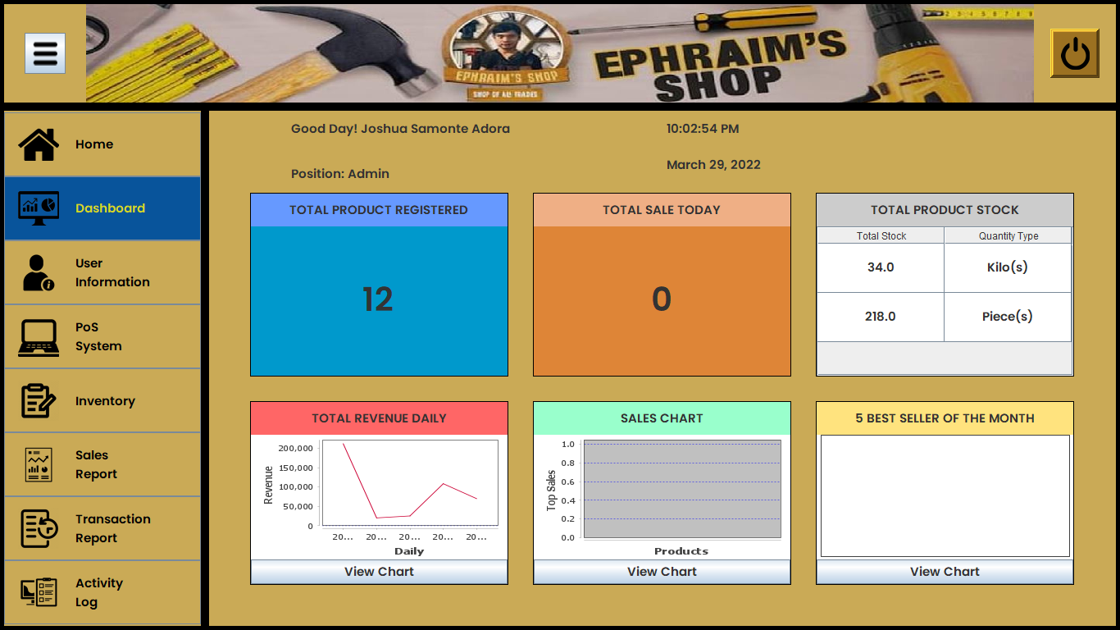

**Figure 3.5 The Dashboard Interface**

**User’s Information Frame**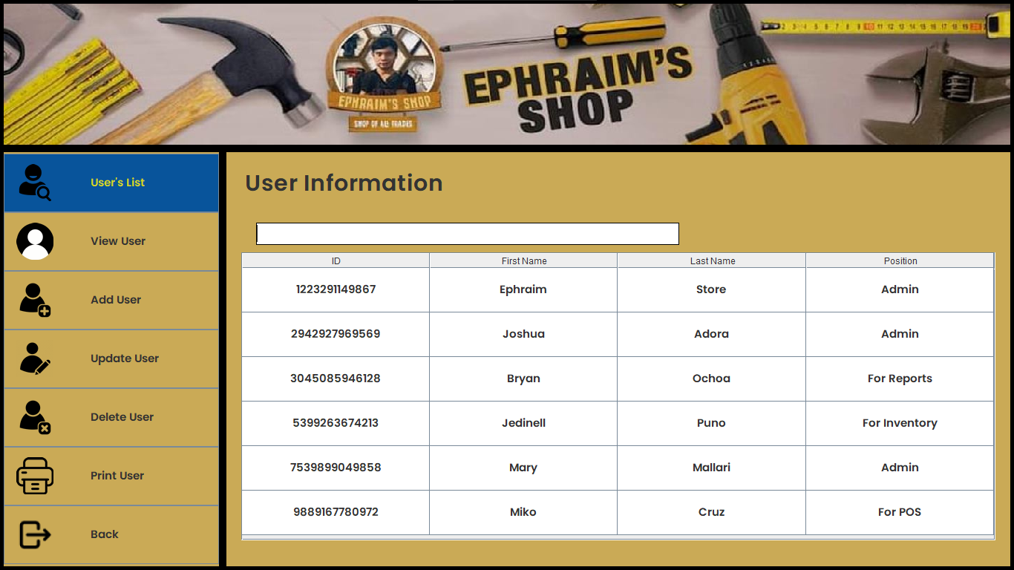

**Figure 3.6 The System User’s List Interface**

**View User’s Information Frame**

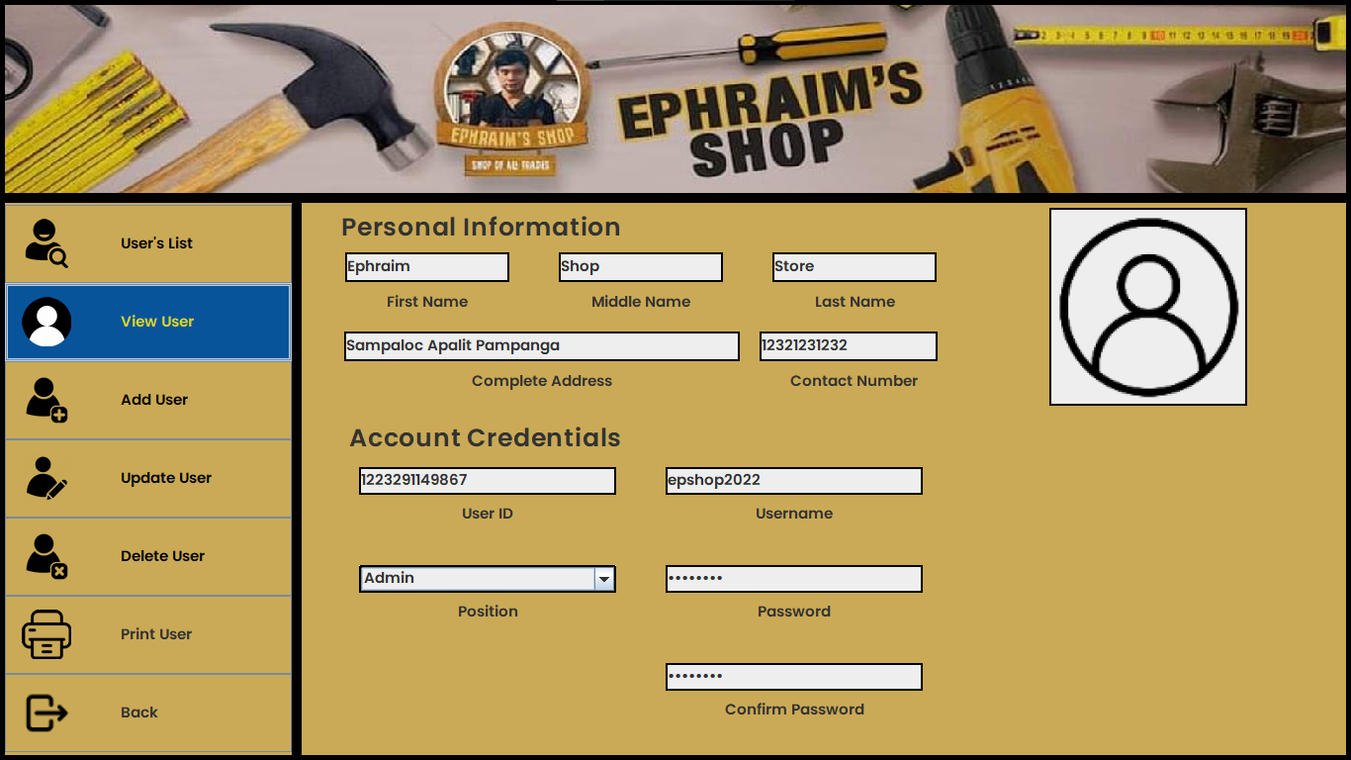

**Figure 3.7 The System View User’s Information Interface**

**Add User’s Information Frame**

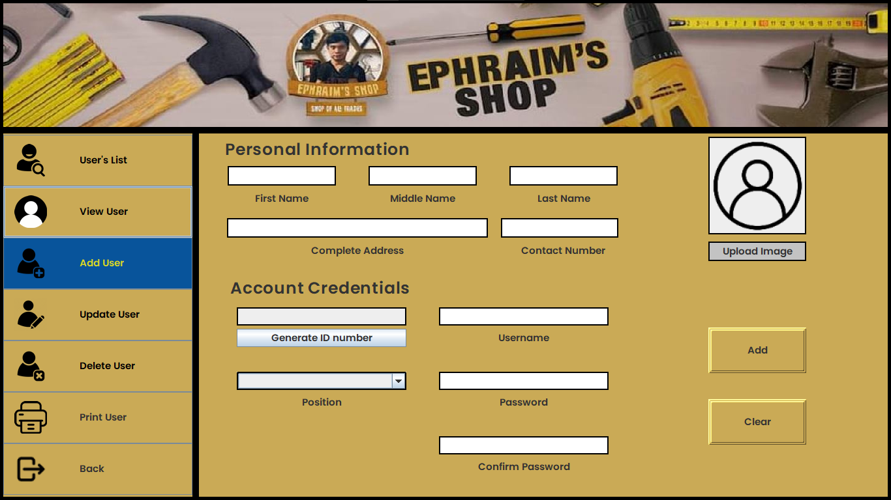

**Figure 3.8 The System Add User’s Information Interface**

**Update User’s Information Frame**

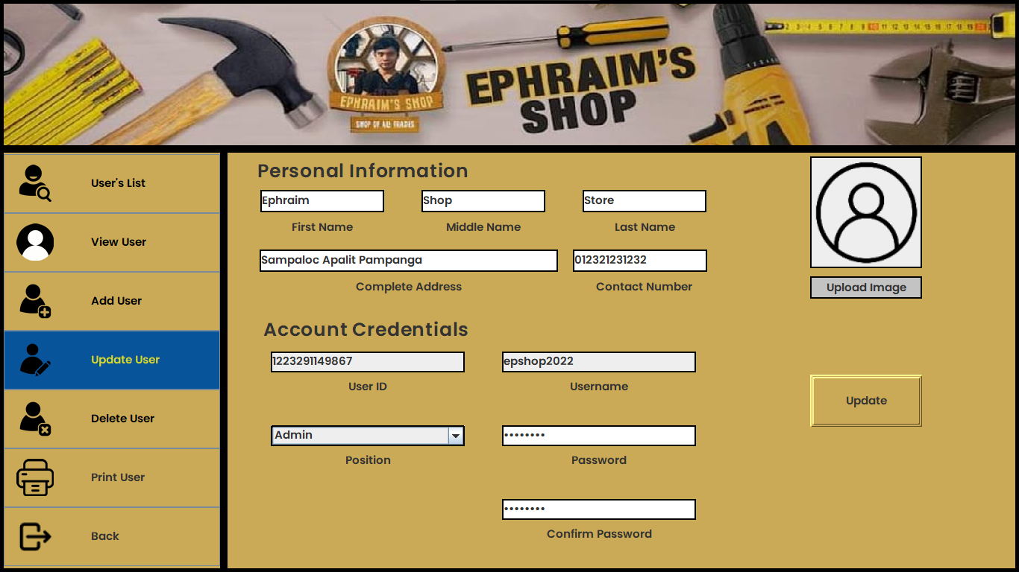

**3.9 The Update User’s Information Interface**

**Payment Frame**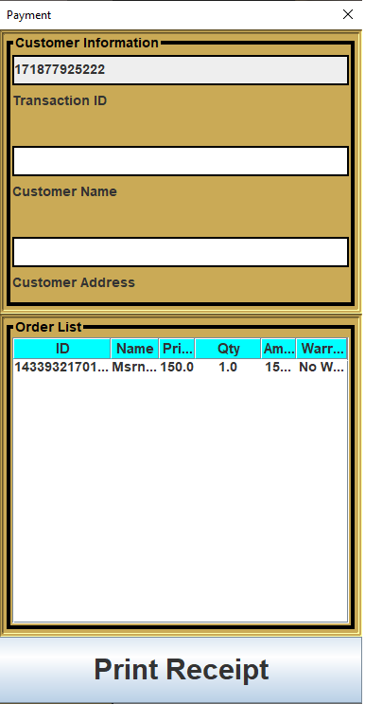

**Figure 3.10 The System Payment Interface**

**Inventory Frame**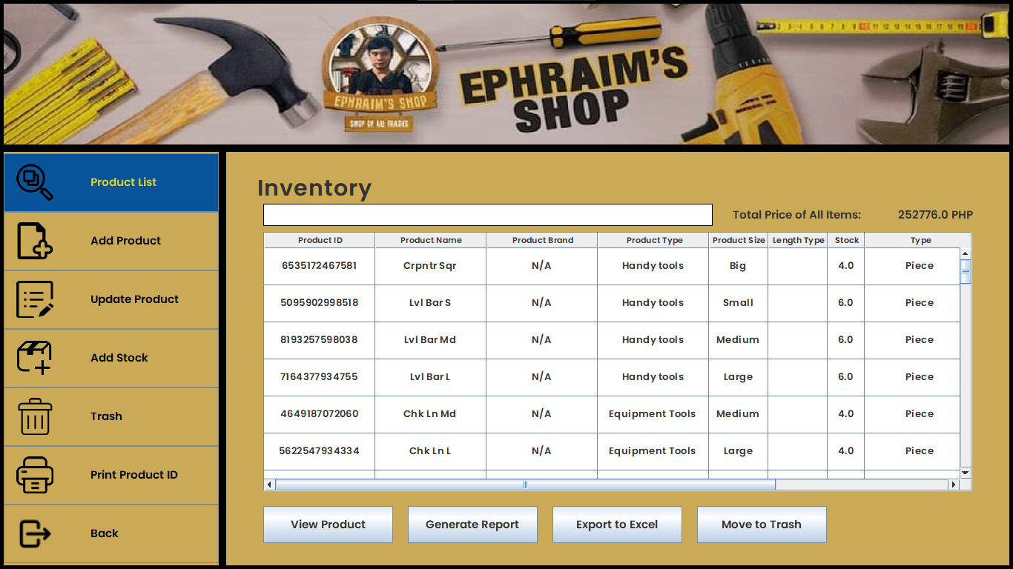

**Figure 3.11 The System Inventory Interface**

**Add Product Frame**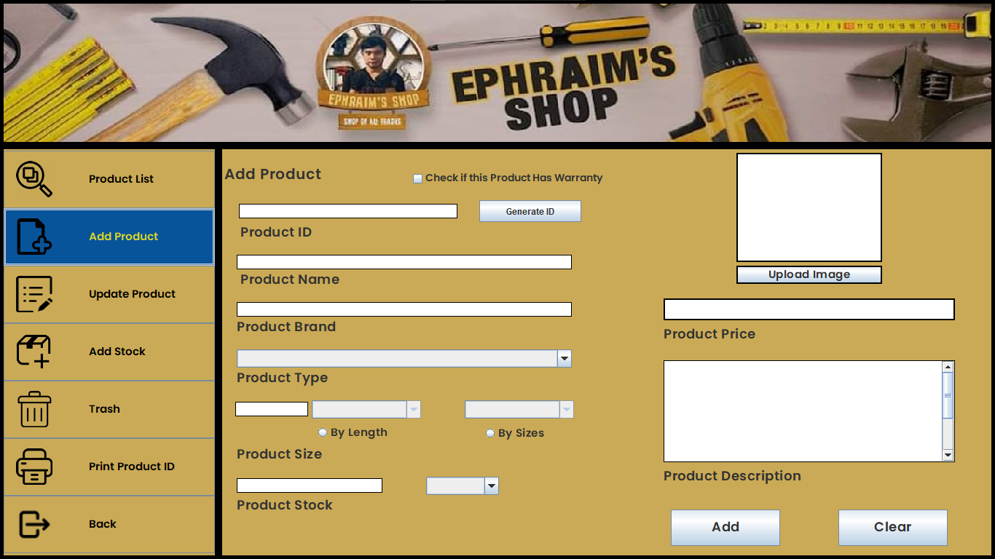

**Figure 3.12 The System Add Product/Item Interface**

**Update Product Frame**

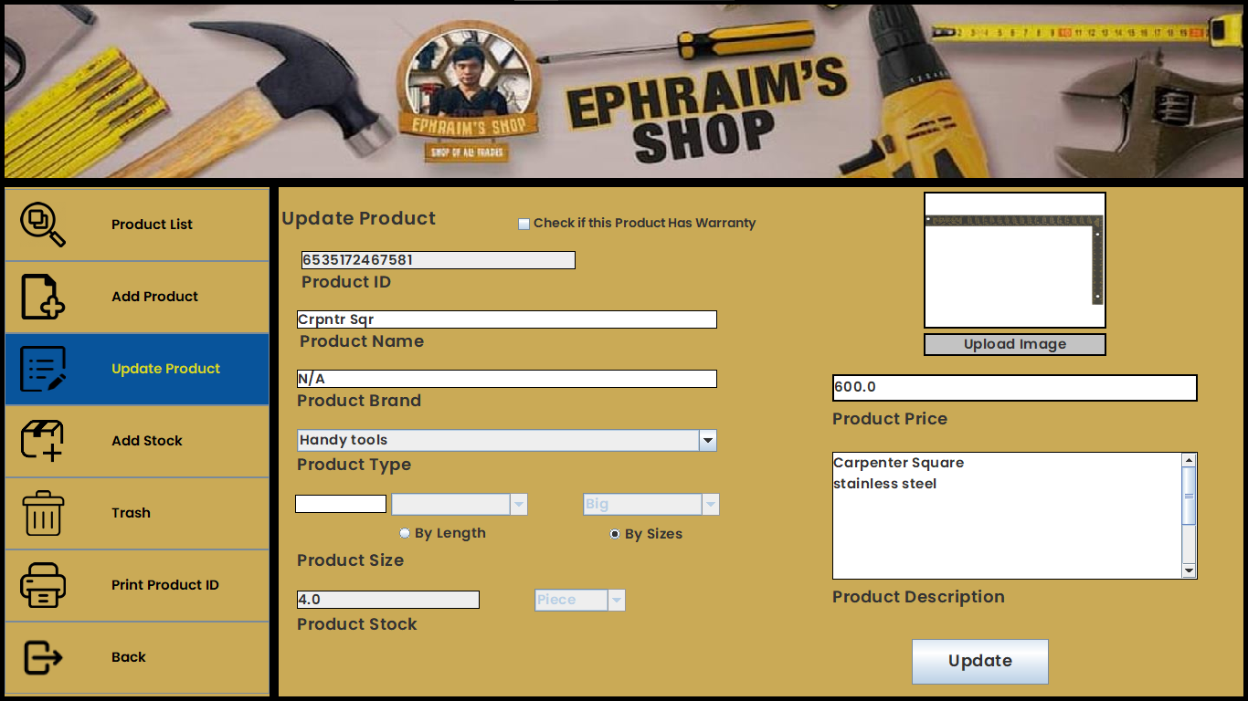

**Figure 3.13 The System Update Product/Item Interface**

**Add Stock Frame**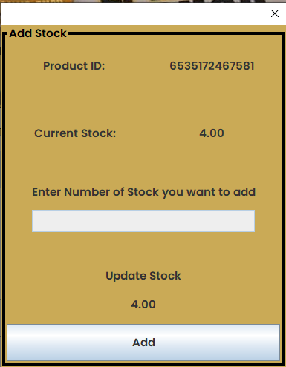

**Figure 3.14 The System Add Number of Stock Interface**

**View Product Frame**

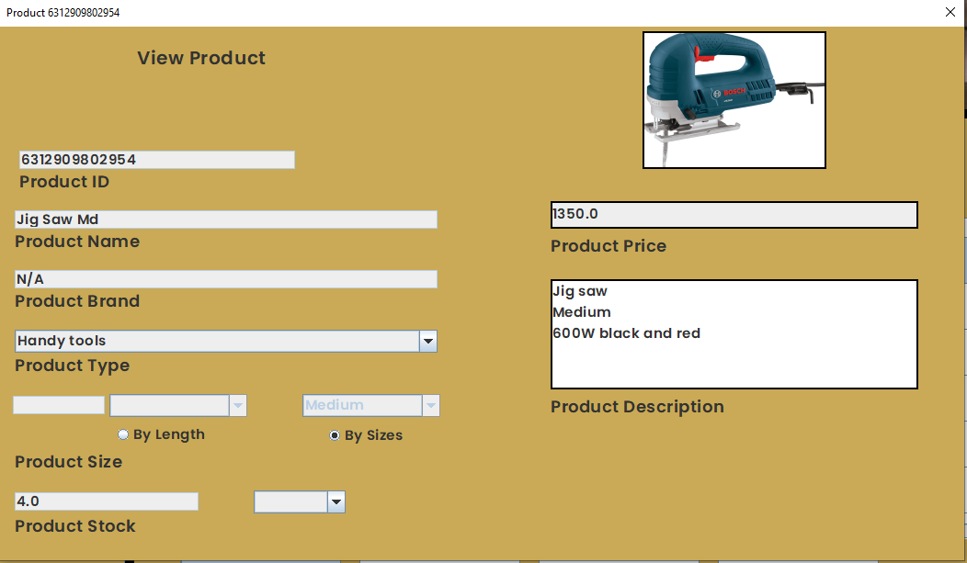

**Figure 3.15 The System View Product/Item’s Information Interface**

**Trash Product Frame**

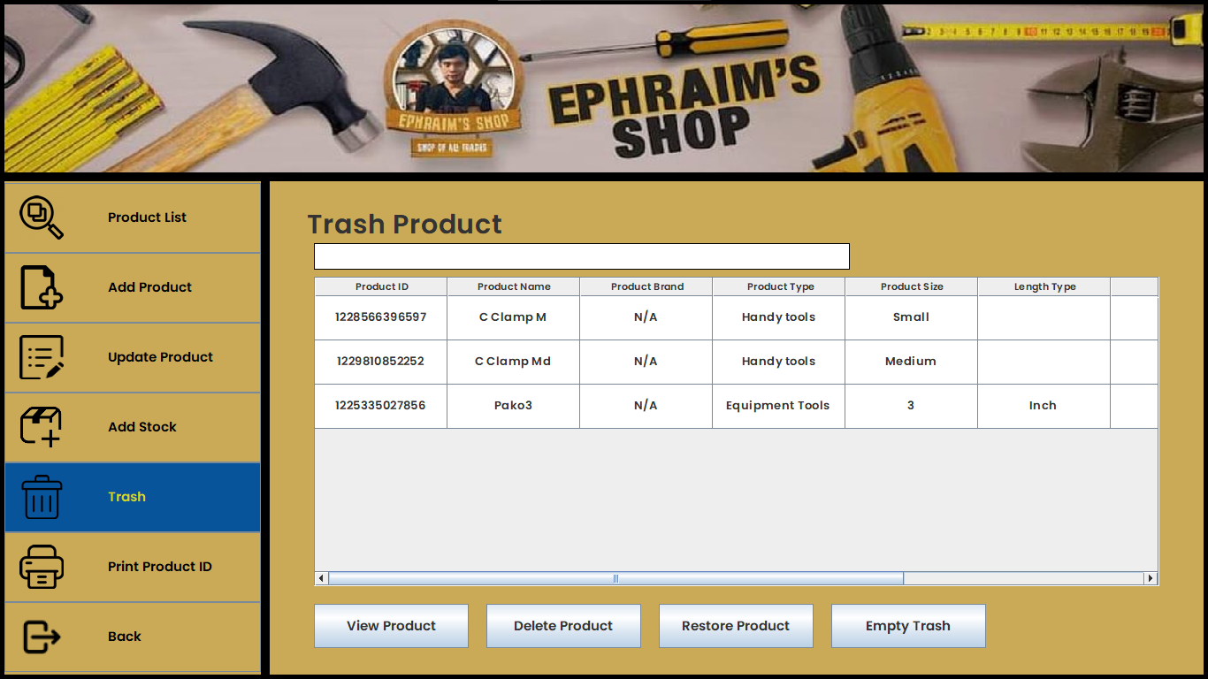

**Figure 3.16 The System Trash/Recycle Bin Product Interface**

**Inventory in PDF File**

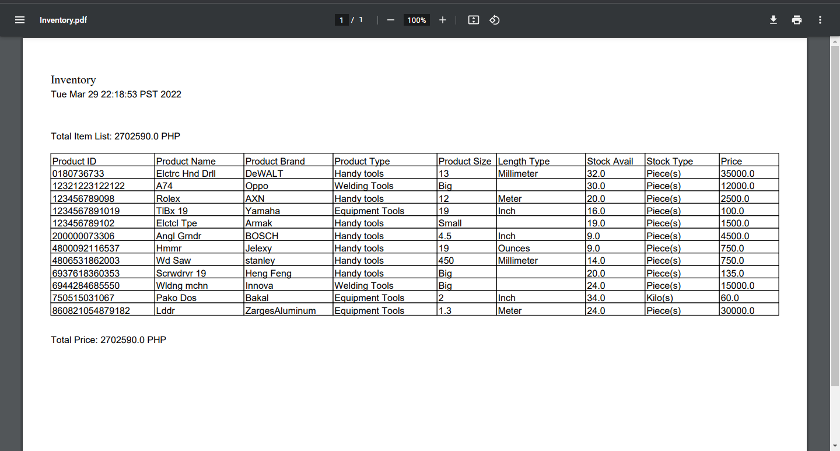

**Figure 3.17 The Generated Inventory Data in PDF File**

**Inventory in Excel File**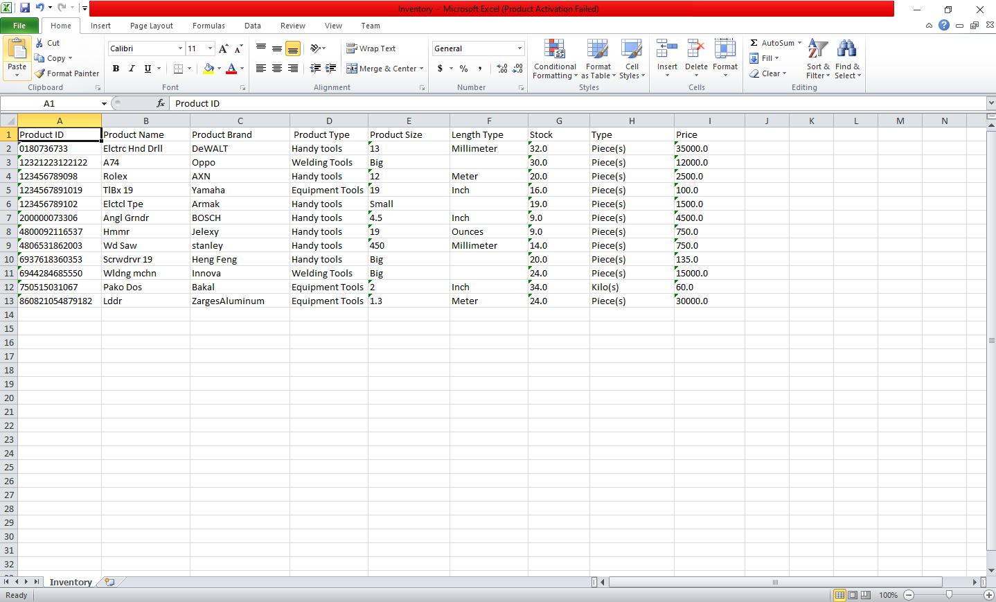

**Figure 3.18 The Generated Inventory Data in Excel File**

**Transaction Report Frame**

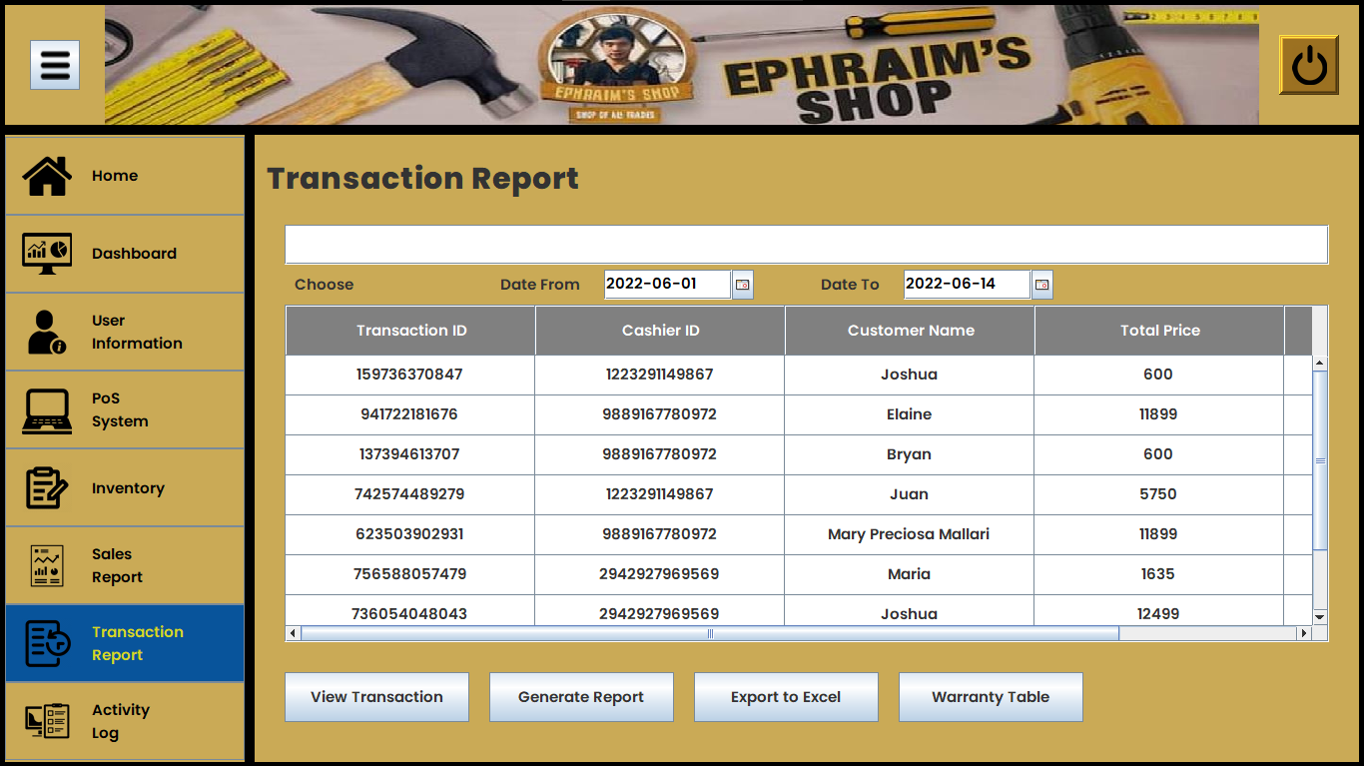

**Figure 3.19 The System Transaction Report Interface**

**View Transaction Frame**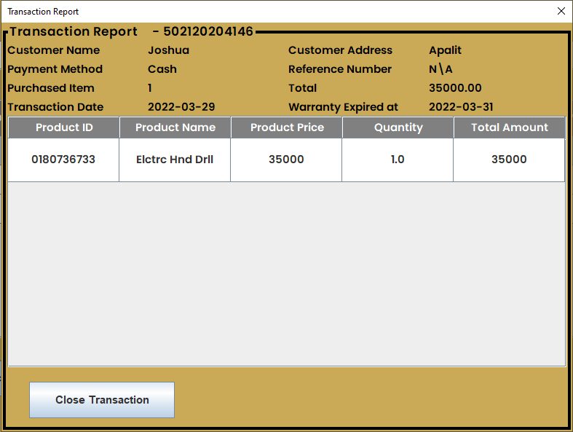

**Figure 3.20 The System View Transaction Interface**

**Request Warranty Frame**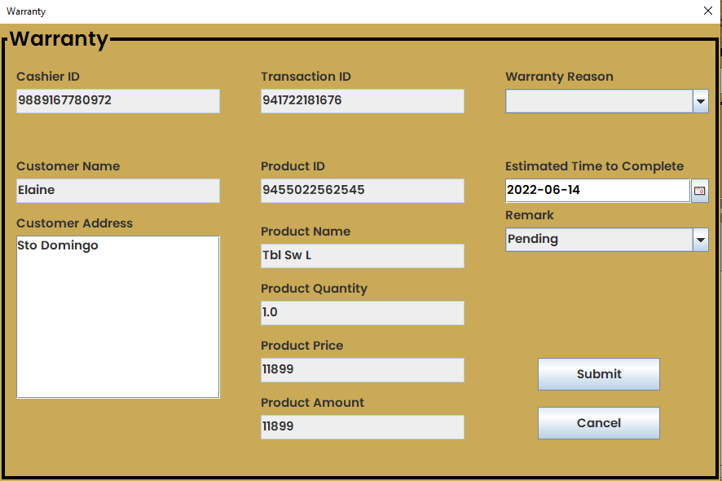

**Figure 3.21 The Request Warranty Interface**

**Warranty List Frame**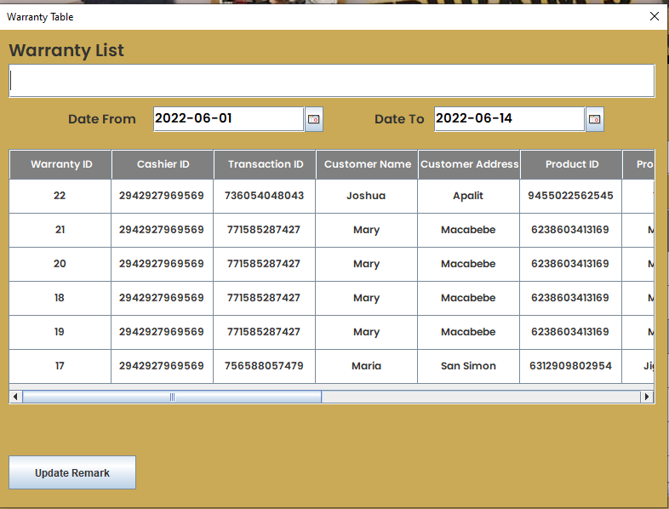

**Figure 3.22 Warranty Table Interface**

**Transaction Report in PDF File**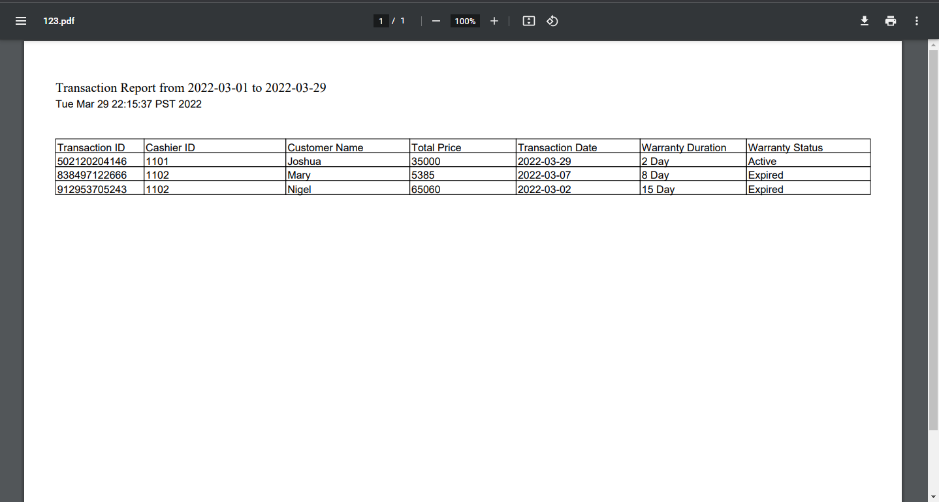

**Figure 3.23 The Generated Transaction Report in PDF File**

**Transaction Report in Excel File**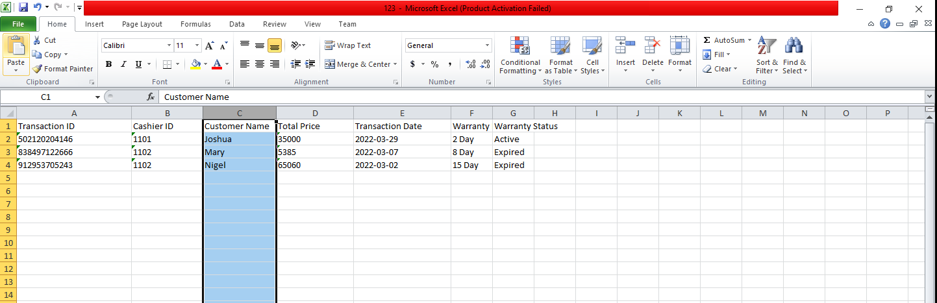

**Figure 3.24 The Generated Transaction Report in Excel File**

**Activity Log Frame**  
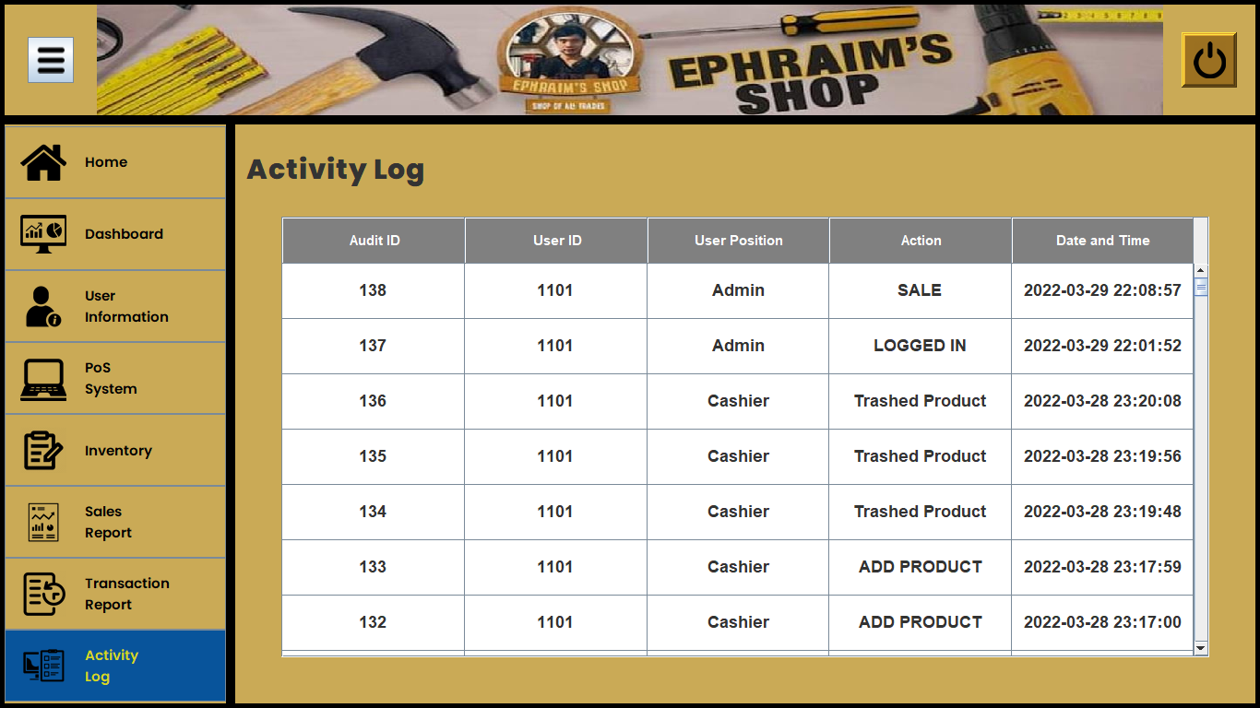

**Figure 3.25 The System Activity Log Interface**

**Sales Report Frame**

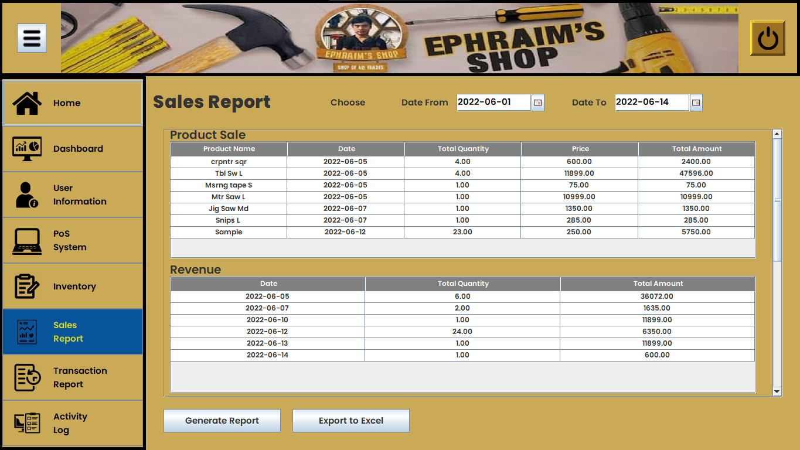

**Figure 3.26 The System Sales Report Interface**

**Generated Sales Report in Excel File**

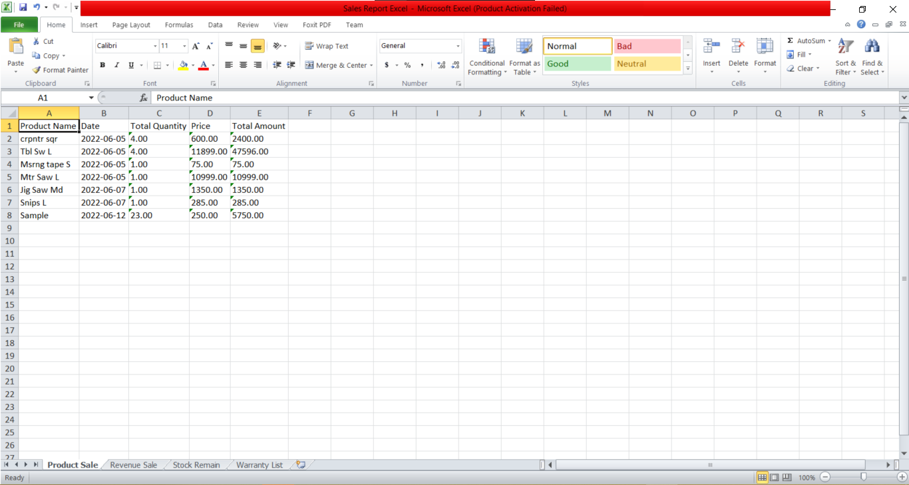

**Figure 3.27 Generated Sales Report in Excel File Form**

**Generated Sales Report in PDF File**

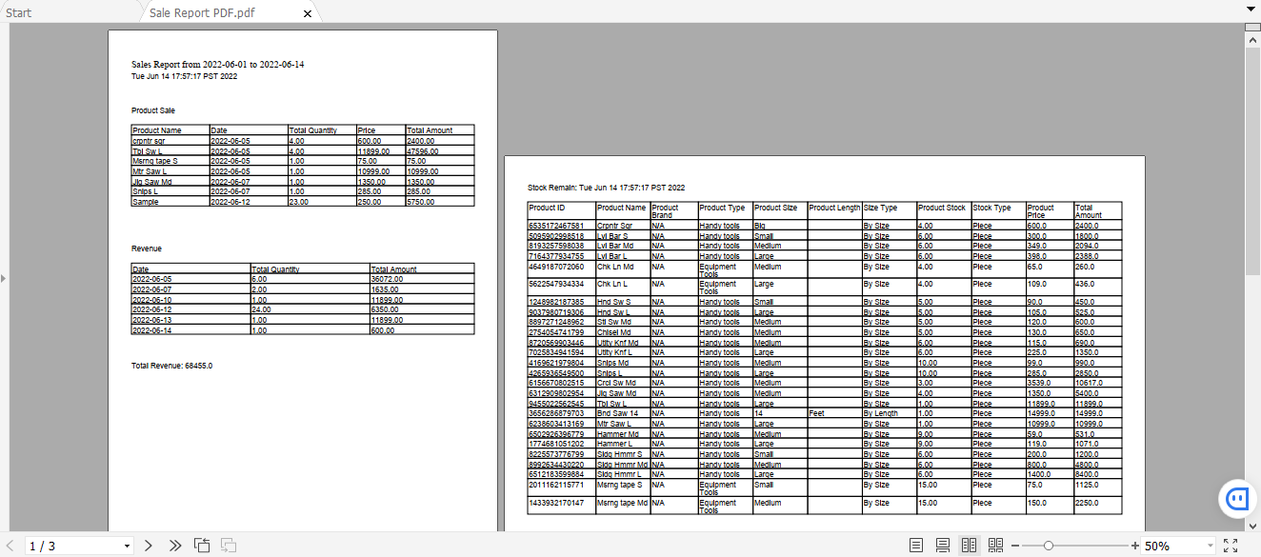

**Figure 3.28 Generated Sales Report in PDF File Form**

**PROJECT EVALUATION**

This section shows the result of the survey for the point of sales and inventory systems for Ephraim’s hardware shop. This conducted survey will help the researchers with the improvement of the proposed system.

According to ISO 9126 standards, each system user was given a system evaluation questionnaire to complete after using the system. Functionality comes first, followed by reliability and usability, efficiency criteria, and then maintainability criteria. The existence of a set of functions and their stated properties is determined by a set of attributes.

| **FUNCTIONALITY** |
| --- |
| **Item** | **5** | **4** | **3** | **2** | **1** | **Mean** | **Descriptive Interpretation** |
| All the functions of the system meet the business needs. | 9 | 1 | 0 | 0 | 0 | 4.90 | Strongly Agreed |
| The system generates accurate output. | 9 | 1 | 0 | 0 | 0 | 4.90 | Strongly Agreed |
| Security, Provision for security requirements. | 6 | 4 | 0 | 0 | 0 | 4.60 | Strongly Agreed |
| **Total Mean** | | | | | | **4.80** | **Strongly Agreed** |

**Figure 3.22 The Functionality Survey’s Final Tally**

| **RELIABILITY** |
| --- |
| Item | 5 | 4 | 3 | 2 | 1 | Mean | | **Descriptive**  **Interpretation** | |
| The system does not need further development | 5 | 5 | 0 | 0 | 0 | 4.50 | | In-between of Strongly Agreed and Agreed | |
| The system works with minimal errors | 3 | 5 | 2 | 0 | 0 | 4.60 | | Agreed | |
| If power failure occurs, the system can. | 3 | 2 | 4 | 1 | 0 | 3.70 | | Undecided | |
| **Total** | | | | | | | **4.26** | **Undecided to Strongly Agreed** |

**Figure 3.22 The Reliability Survey’s Final Tally**

| **USABILITY** |
| --- |
| **Item** | **5** | **4** | **3** | **2** | **1** | **Mean** | **Description Interpretation** |
| The system is user-friendly. | 7 | 3 | 0 | 0 | 0 | 4.70 | Strongly Agreed |
| The user can easily learn the function of the system. | 7 | 3 | 0 | 0 | 0 | 4.70 | Strongly Agreed |
| All the features work according to their function. | 7 | 3 | 0 | 0 | 0 | 4.70 | Strongly Agreed |
| The system provides desirable outputs for the users. | 7 | 3 | 0 | 0 | 0 | 4.70 | Strongly Agreed |
| **Total** | | | | | | **4.70** | **Strongly Agreed** |

**Figure 3.22 The Usability Survey’s Final Tally**

| **SECURITY** |
| --- |
| **Item** | **5** | **4** | **3** | **2** | **1** | **Mean** | **Description Interpretation** |
| Your personal data is secured. | 7 | 3 | 0 | 0 | 0 | 4.70 | Strongly Agreed |
| Spamming Random Password | 6 | 4 | 0 | 0 | 0 | 4.60 | Strongly Agreed |
| **Total** | | | | | | **4.65** | **Strongly Agreed** |

**Figure 3.22 The Efficiency Survey’s Final Tally**

| **MAINTAINABILITY** |
| --- |
| **Item** | **5** | **4** | **3** | **2** | **1** | **Mean** | **Description Interpretation** |
| The user can manipulate the system easily. | 8 | 2 | 0 | 0 | 0 | 4.80 | Strongly Agreed |
| The system can adapt data changes and updates. | 8 | 2 | 0 | 0 | 0 | 4.80 | Strongly Agreed |
| System has stable storage of data. | 8 | 2 | 0 | 0 | 0 | 4.80 | Strongly Agreed |
| **Total** | | | | | | **4.80** | **Strongly Agreed** |

**Figure 3.22 The Maintainability Survey’s Final Tally**

**CHAPTER V**

**SUMMARY**

The Ephraim’s hardware shop's point of sale and inventory system provides a complete sales and inventory system capable of providing customers and partners with quick access to sales and inventory conditions.

Ephraim's hardware shop experienced several difficulties. One of them is that the data records they manually entered do not match. Another issue is that they have trouble keeping track of what has been sold at times. Creating an automated or computerized point of sale and inventory system is the solution to these issues. They will save time and be able to process their items more efficiently as a result of this method. It's a painless, quick, and straightforward procedure. The system has the ability to create, update, and delete data. It also offers a transaction technique that ensures that every item purchased by a customer is automatically registered in the inventory. The user must first submit his or her id and password to access the inventory, transaction process, data update, and deletion. The inventory contains a list of products, their quantities, and their prices.

A system's usability, functionality, efficiency, reliability, and maintainability were evaluated by a survey. The results of the poll are favorable, with the majority of respondents being very satisfied (5) and satisfied (4). The researchers were able to satisfy the owner and cashier using this method. The researchers were shown around the system and given information on its features and functions. This approach, according to the experts, can help the business complete more transactions and expand. And the system is able to address the system's problems more quickly and with less effort.

**CONCLUSION**

Their inefficient manual inventory and record-keeping techniques are automated by a computerized point of sale and inventory system. The shop ran into a number of issues and problems, including an inefficient method of recording sales transactions, which resulted in lost sales. An inconsistent method of handling receipts, which can be time-consuming, and an inconsistent method of monitoring inventory status, which resulted in out-of-stock situations.

Customer issues were discovered, and the study was conducted using research and observations. Testing, system analysis, and evaluation, on the other hand, significantly improved the developer's knowledge and skills. The system's functionality, efficiency, maintainability, usability, and reliability are all evaluated.

**RECOMMENDATION**

Online Reservation for the item that is wanted by customers but not in the store yet. The System doesn’t have a discount on every item/product yet. The system doesn’t have an online payment, it makes the system more features. The system is not able to get information on the internet, it makes the system easier-to-use. The system doesn't cover Refund process

**REFERENCES**

https://www.storehub.com/ph/blog/pos-system-benefits/?fbclid=IwAR2lFWS2IWsKAyI6HM7vSAApd6yP-aDCnSaC_WUMX07qn8FD7N_t-GEQBqc

<https://asia.nikkei.com/Business/Companies/Digital-payment-grows-in-Philippines-amid-COVID-19-fears>

<https://www.investopedia.com/terms/p/point-of-sale.asp>

(<https://www.thebalancesmb.com/what-is-a-pos-system-for-inventory-management-393398>)

<https://www.businessnewsdaily.com/6499-pos-changes.html>

<https://www.forbes.com/advisor/business/software/point-of-sale/>

https://squareup.com/us/en/townsquare/what-pos-system

<https://www.softwareadvice.com/resources/what-is-a-point-of-sale-system/>

<https://www.mckinsey.com/business-functions/marketing-and-sales/our-insights/sales-automation-the-key-to-boosting-revenue-and-reducing-costs>

<https://www.theglobaltreasurer.com/2016/05/02/case-study-automated-payments-and-dynamic-discounting-fuel-growth-at-mediafly/>

<https://www.researchgate.net/publication/303031780_AutoCRUD_-_Automating_IFML_Specification_of_CRUD_Operations>

<https://jinisyssoftware.com/importance-of-point-of-sales-pos-software-in-the-philippines/>

<https://www.researchgate.net/publication/281580313_System_reliability_performance_and_trust_in_adaptable_automation>

<https://www.isaca.org/resources/news-and-trends/isaca-now-blog/2018/automated-systems-and-security-threats-and-advantages>

http://www.posworldphilippines.com/possoftwares.html